Practical - 8
Practical Title: MySQL Schema Design, ER Model, PDO Connectivity, and Prepared Statements
Design the database for StudentHub with students, events and registrations. Create PHP database connection using MYSQL statements.

Theory

1. Is the schema normalized properly?
- Database credentials are stored in a separate db.php file.
- The database connection is established using PHP and MySQL.
- Prepared statements are used to prevent SQL injection.
- User passwords should be hashed using password_hash() before storing them.
- Database credentials should not be exposed publicly.
- For production, use environment variables and HTTPS for better security.

2. Are primary keys and foreign keys correctly defined?
- Primary keys: Correctly defined to uniquely identify each record in a table. They cannot contain duplicate or NULL values.
- Foreign keys: Correctly defined to establish relationships between tables by referencing the primary key of another table.
- Conclusion: Yes, primary keys and foreign keys are correctly defined if they maintain uniqueness and referential integrity.

3. Is the database connection handled securely?
- The schema is properly normalized if it follows 1NF, 2NF, and 3NF.
- 1NF: Each column contains atomic (single) values, with no repeating groups.
- 2NF: Every non-key attribute depends on the entire primary key.
- 3NF: No non-key attribute depends on another non-key attribute.
- Redundancy: Data duplication is minimized, reducing insertion, update, and deletion anomalies.
- Conclusion: If all these conditions are satisfied, the schema is normalized up to 3NF.
Implementation/Output/Result:
Designed the StudentHub database with students, events, and registrations tables using MySQL. Created an ER model to define relationships between the tables. Implemented PHP database connectivity using PDO and prepared statements for secure and efficient database operations.

Evidence of Work (Screenshots)
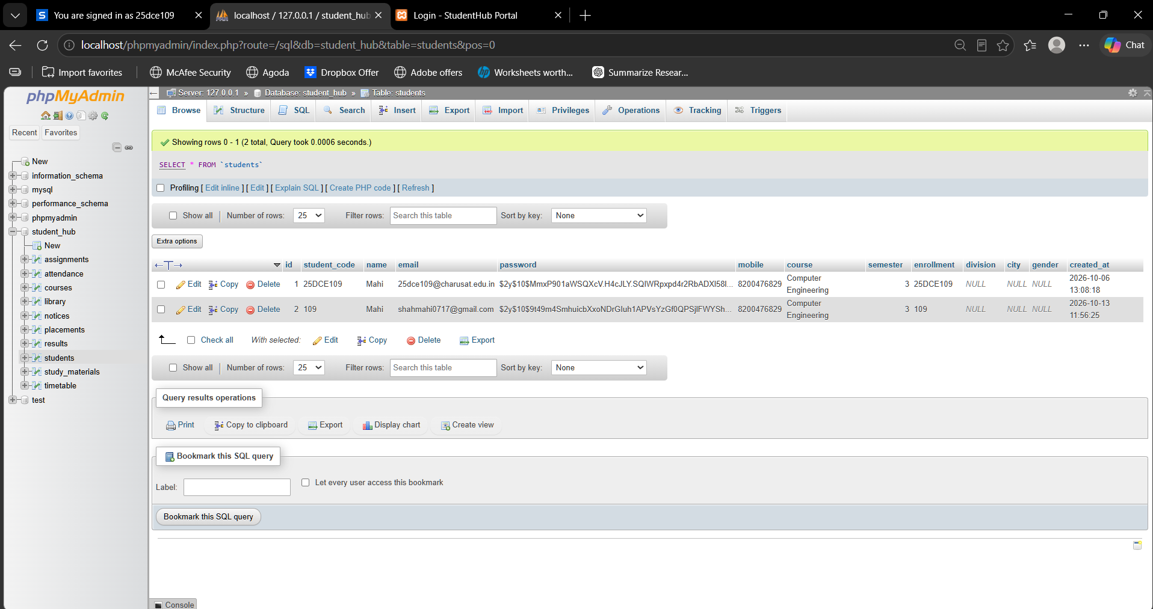
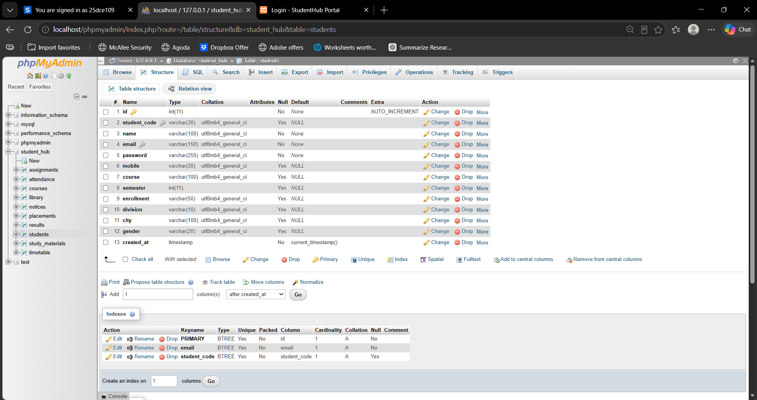
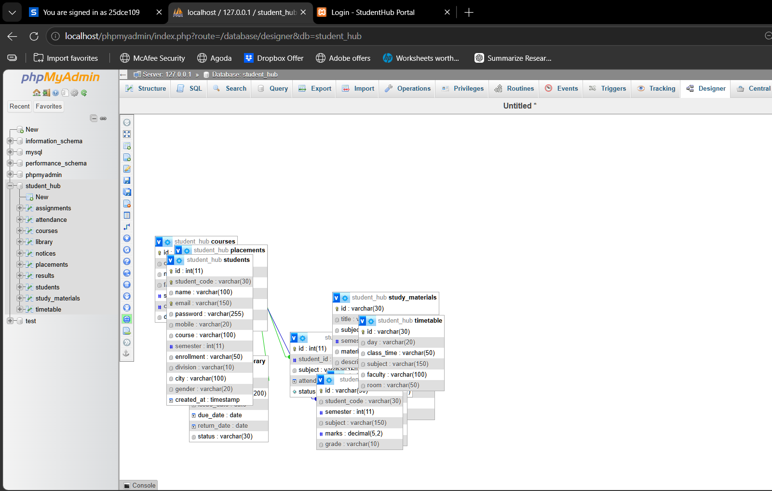

GitHub Repository Link: https://github.com/shahmahi0717/Student-Hub-Portal

Challenges Faced:
• Designing appropriate tables, primary keys, and foreign keys.
• Establishing a connection between PHP and MySQL using PDO.
• Using prepared statements to prevent SQL injection.

Learning Outcomes:
- Learned database schema design and ER modeling.
- Understood primary keys, foreign keys, and table relationships.
- Gained practical knowledge of PHP–MySQL connectivity using PDO.
- Learned to use prepared statements for secure database queries.

Faculty Remarks:

